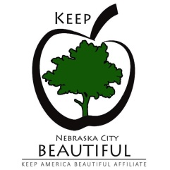
ANNUAL MEMBERSHIP FORM
Keep Nebraska City Beautiful
This organization receives partial funding from NDEE (Nebraska Department of Environment and Energy), memberships and other fundraising projects. Your membership and support of KNCB (Keep Nebraska City Beautiful) will help us reach our goals for the coming year.
Name:________________________________ Organization/Company:____________________________
Mailing Address (Street or PO Box):________________________________________________________
City:________________________________________ State:_________________ Zipcode:____________
Email:_______________________________________ Telephone: _______________________________
___ Emerald ($1000 or more for one year) | ___ Mint Green ($500 for one year)
___ Spring Green ($200 for one year) | ___ Olive Green ($100 for one year)
___ Tree ($50 for one year) | ___ Leaf ($25 for one year)
___ Other donation/amount:
Membership at certain levels entitles you to several benefits. Please indicate the benefits you would like to receive below:
For Emerald, Mint Green, and Spring Green members only:
___ Corporate logo on our website and social media
___ Sponsorship recognition on our website, FB, and other communications
For Emerald only – all of the above plus:
___ NC Receptacle advertising
___ Membership Plaque
No gift: ___ Please utilize my full contribution for educational programs; do not send gift(s).
Memberships run from date of receipt of payment through December 31st of the same calendar year.
Please make checks payable to and return this form to:
Keep Nebraska City Beautiful Phone: 402-873-9043
1902 4th Corso, Suite 1 email: keepnebcitybeautiful@gmail.com
Nebraska City, NE 68410 website: keepnebraskacitybeautiful.com

